Humanitarian project
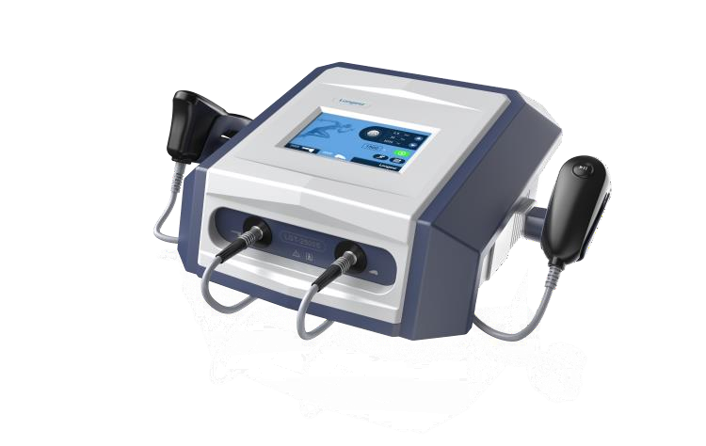
Health care institution "Borisov Central District Hospital"
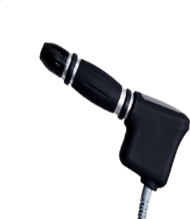
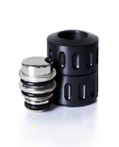
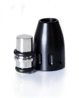
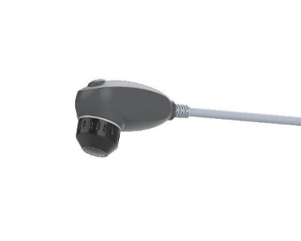
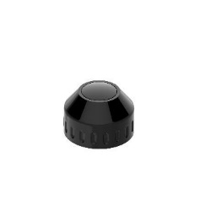

1. Project name:
“Improving the quality of rehabilitation care for the adult population with diseases of the musculoskeletal system in the health care institution “Borisov Central District Hospital.”

2. The project implementation period is 2024-2025.

3. The applicant organization proposing the project is the health care institution “Borisov Central District Hospital”.

4. Project goals:
- implementation of modern technologies of medical rehabilitation for patients with diseases of the musculoskeletal system;
- improving the quality of life of patients with diseases of the musculoskeletal system ;
- reducing the risk of disability for patients with diseases of the musculoskeletal system.

5. Tasks planned for implementation within the framework of the project:
- organization of rehabilitation assistance at a modern high-tech level;
- introduction into the medical rehabilitation program for patients of a method whose therapeutic effect is based on deep penetration of acoustic waves into the body;
- ensuring high quality and accuracy of the impact of waves on the affected area by individual selection of the strength and frequency of vibration impulses.

6. Target group:
- the project is designed for patients with diseases and injuries of the musculoskeletal system who are undergoing rehabilitation at the health care institution “Borisov Central District Hospital”.

7. Brief description of activities within the project:
- shock wave therapy (SWT) is a medical procedure that improves regeneration and blood circulation in various tissue structures. In addition, the method has a pronounced analgesic and anti-inflammatory effect;
- the effect of the shock wave therapy device is due to the formation of short, clearly directed vibration pulses that change the structural composition of damaged cells. The generated sound waves pass through soft tissues deep into the body, stopping only in the area of dense anatomical structures;
- increased blood circulation almost immediately removes destroyed particles of inflamed cells and promotes their rapid resorption by microphages. Whole, healthy tissues do not respond to shock wave pulsation, since the elastic structure of undamaged cells allows the impulse to pass freely.
Due to similar physical properties, acoustic vibrations lead to a “massage” of the listed structures and the development of the following biological effect:
- blood flow and outflow of lymphatic fluid increases;
- swelling of soft tissues decreases;
- anti-inflammatory effect develops;
- by reducing the tone of smooth muscles and skeletal muscles, the severity of pain is reduced;
- tissue regeneration improves;
- the sensitivity of nerve formations and receptors decreases.

Advantages of UVT:
- acceleration of restoration of damaged tissues;
- relief from spasms and muscle relaxation;
- increasing the level of mobility of the articular apparatus.

Indications for use of UVT:
- pain in the neck and back caused by diseases and injuries of the spine, including hernias and protrusions of intervertebral discs;
- humeroscapular periarthritis;
- pain in the hands;
- numbness in the arms and legs;
- heel spur;
- ulnar epicondylitis (“tennis elbow” and “golfer’s elbow”);
- arthrosis of the hip, knee and ankle joints with pain;
- muscle pain;
- limitation of joint mobility (contractures) caused by injury or other disease;
- pain along the tendons;
- pain associated with increased muscle tone;
- consequences of sports injuries and many other problems of the musculoskeletal system;
- rehabilitation after diseases of the musculoskeletal system.

Unique features of the UVT device:
- blood supply and lymphatic drainage in tissues improves, which normalizes redox reactions, promotes the removal of inflammatory products, and reduces swelling;
- regeneration processes are activated, the growth of new capillaries is stimulated (due to the synthesis of vascular endothelial growth factor in tissues), as well as local processes of cellular immunity;
- the analgesic effect of UVT occurs from the first procedure and lasts from several hours to a day, and after several sessions the pain syndrome often completely disappears;
- improving the structure and elasticity of ligaments, muscles and other tissues, softening scars and inflammatory infiltrates, relieving muscle spasticity ;
- increased range of motion in joints;
- elimination of trigger points;
- reduction of calcium deposits.

8. Total amount of financing ( in US dollars at the exchange rate of the National Bank of the Republic of Belarus) – 20500.

Source of financing | Amount of funding  (in US dollars at the exchange rate of the National Bank of the Republic of Belarus)
Donor funds | 17500
Co-financing (own funds) | 3000
9. Project location (region/district, city):
222120, Borisov, st. 1812, 9.

10. Contact persons:
Gorodetskaya Olga Viktorovna, deputy chief physician,
tel. 8 (0177) 73 30 21, email cvkk@borisov-crb.by

